**What Metrics Should We Use for a Business Intelligence Dashboard?**

Shaun Pritchard

Rasmussen College

QMB3000

Kevin Watts

May 11, 2020

**What Metrics Should We Use for a Business Intelligence Dashboard?**

A business dashboard is an information management tool which can be used to track the KPIs (key performance indicators) and predictions. The metrics, and other business centric key data points available to a business or department. With the use of data visualizations, dashboards can simplify complex data sets to provide users a glance awareness of current performance. The main key points and characteristics the dashboard should implement concepts to facilitate flexibility, portability, and scalability.

For a company that manufactures and distributes supplies for hospitals. it is essential to develop systems based on the specific key metrics. These are metrics I believe would benefit XYZ healthcare. Helping to establish direction and making business decisions facilitate the future of XYZ Healthcare Company and scaling a profitable business.

In order to facilitate metrics that will benefit XYZ Healthcare needs to establish some working strategic goals to help manage the company and save money. We will need to implement performance indicators to evaluate XYZ healthcare. Listed below are the 3 main KPI categories that should be measured to define strategic goals.

**KPI categories to define strategic goals:**

* Finances
* Customers
* Employees

*A description of KPI’s that correlate with these suggested category strategic goals is given below (Durcevic, 2019).*

**Financial**

* **Profit and Loss:** Profit and loss reports are one of the simplest and most effective measures of success. On a basic level this KPI will give XYZ Healthcare an idea of thier business income less expenditures over a period of time. Either showing a profit, or a loss. This KPI is good for several reasons:
  + This report will force XYZ Healthcare to monitor cash expenditures.
  + This report will help XYZ Healthcare identify which months business performs well and which one it does not.
  + This report will also give XYZ Healthcare an overall sense of your growth over time.
* **Revenue vs. Target:** This is a basic comparison that measures your actual revenue versus what you projected to make. By analyzing the discrepancies between these numbers, XYZ Healthcare can determine how business is performing towards its revenue goals.
* **Expenses vs. Budget:** Here XYZ Healthcare can compare your actual overhead costs with your allotted budget. Measuring this will help become more financially responsible with the company’s capital over time.

**Customer**

* **Customer Acquisition Cost (CAC):** This metric essentially tells XYZ Healthcare how much it costs to bring on a new customer. This is an extremely important metric. This can be calculated using the following formula over a given period of time: *(total amount spent acquiring new customers) / (number of new customers) = (Customer Acquisition Cost).*
* **Customer Churn Rate (CCR):**This metric measures the percentage of customers that fail to become a repeat customer or discontinue service during a period of time. This can be calculated using the following formula over a given period of time: *(Number of Customers lost) / (Total number of customers) = (Customer Churn Rate).*
* **Customer Lifetime Value (CLV):**This metric lets XYZ Healthcare measure the total value from a long-term customer relationship. Helping to focus on sales and marketing efforts.

**Employee**

* **Success of Customer Training:** This essentially shows how effective XYZ Healthcare employee trainings are. Hiring and training new employees can be expensive regardless the size of your business. The most effective way to do this is to create a before and after test measuring overall knowledge. The more employees churning in and out the more accurate this measurement will be.
* **Employee Turnover Rate (ETR):** This can be found by dividing the number of employees who have left the company by the average number of employees. If there is a high ETR then it is probably a good idea to examine the company culture and work environment.
* **Employee Satisfaction:** This can be determined using a multitude of strategies. The easiest way to do so is to create a basic survey.

**Examples of common performance dashboard**

Here is an example of a KPI dashboard we can implement from the extracted transformed data from XYZ healthcare to facilitate the objectives listed above.

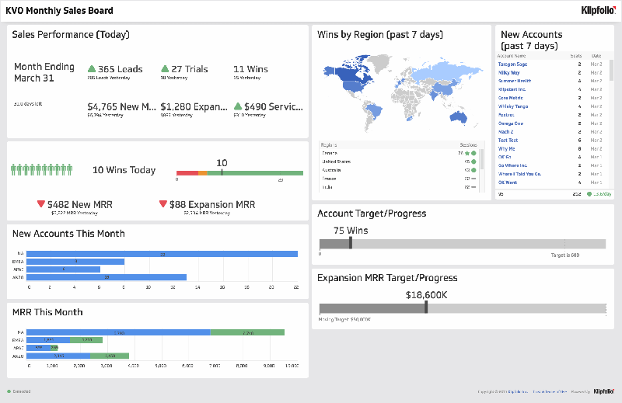

KPI dashboards transform the raw data through the technology we have suggested to implement which can give XYZ healthcare key insights and accountability to business practices, formulating new system, process, and predictions for future events *(Insightsquared, 2019)*.

There are two standard practices for evaluation that can help businesses determine whether those particular performance indicators will be effective: the “SMARTER” criteria and the “6 A’s”. listed below.

**Effective KPI Management: SMARTER Practice**

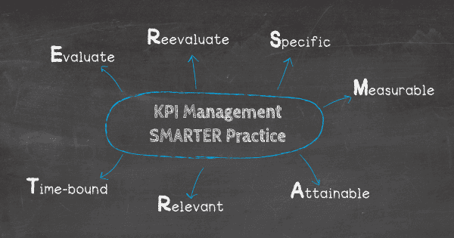

* **Specific:** Start with a specific objective that can be isolated.
* **Measurable:** Find a definitive way to measure the data that needs recording.
* **Attainable:** Make sure the objective is something that can be readily attained
* **Relevant:** Ask if these goals are relevant to the target groups.
* **Time-bound:** Create timeframes and deadlines to accurately measure the KPI.
* **Evaluate:** See if the KPIs provides the actionable data needed to achieve set goals.
* **Reevaluate:** Test and retest for consistency before regular implementation.

**KPI Best Practices: The Six A’s**

* **Aligned:** The KPI aligns with the activities of its specific targets. As long as business continues as normal, collecting the data should be effortless.
* **Attainable:** The indicator is easily attainable so that it can be measured. If data does not start regularly flowing once the trial has begun, there may be something amiss.
* **Acute:** The KPI makes others well-informed, or acute, of the goal and its measurement. If the purpose of the KPI is at all unclear, it may be a sign to try a different indicator.
* **Accurate:** The data pulled from a KPI will be used to accomplish future objectives; it must be reliable and accurate so that it does not lead to any misinterpretation.
* **Actionable:** KPI results produce data that influences a plan of action. KPIs should fuel new processes – if there is no follow-up, then the metric loses its value.
* **Alive:** The data can be leveraged throughout the company’s lifespan. It should become a constant throughout an ever-evolving business.

I hope the above information answered your question David please contact me if you have any questions. I would be happy to discuss it further.

**References**

Arkieva. (n.d). Top 10 Demand Planning Metrics You Should Have on Your Dashboard. Retrieved from arkieva.com: https://blog.arkieva.com/top-10-demand-planning-metrics/

Insight squared. (2019). Right Metrics for your inside sales team. Retrieved from insightsquared.com: https://www.insightsquared.com/wp-content/uploads/2013/11/The_Right_Metrics_for_your_Inside_Sales_Team_v8.pdf

Klipfolio. (2020). Profit and Loss Report. Retrieved from Klipfolio.com: https://www.klipfolio.com/resources/kpi-examples/financial/profit-loss-report

Durcevic, S. (2019, 02 21). *KPI Management And Best Practices: How To Find The Perfect KPI Solutions?* Retrieved from https://www.datapine.com/: https://www.datapine.com/blog/kpi-management-and-best-practices/